Installments (QSOPS)

Troubleshooting guide

Version 0.0.0

February 23, 2021

QuickFee Limited

|  |  |  |
| --- | --- | --- |
| Approved | Checked | Created |
|  |  |  |

**Contents**

1 Preface 1

1.1 Purpose of the Document 1

1.2 Audience 1

2 L1 Error cases 1

2.1 Landing Page Error 1

2.2 Payment Processing Error 1

3 L2 Error cases 2

3.1 System does not respond 2

# Preface

## Purpose of the Document

The purpose of this document is to provide detailed instructions on how to troubleshoot QSOPS web-application, in case of errors or troubles.

## Audience

This Troubleshooting Guide is targeted to:

* Users who will pay for a service using the QSOP web-application.

# L1 Error cases

## Landing Page Error

In case you wanted to open the landing page to make payment and saw the page below, it means that the link you had been trying to open was broken. You can contact your service provider for the further instructions.

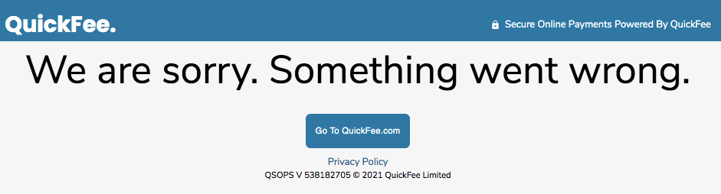

*Figure 1. Landing Page Error*

## Payment Processing Error

If you got any error on while the payment processing, contact Splitit support, their contact details will be provided on the error page.